**Our Safeguarding Team**

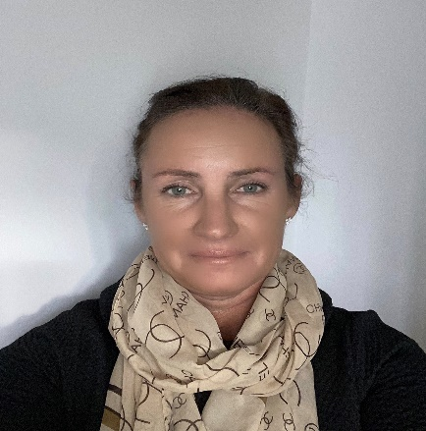

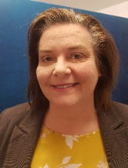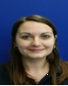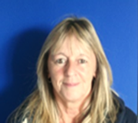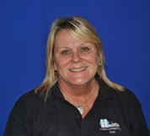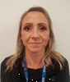

**Duty**

**Maria Allan**

**Duty**

**Debbie Hoyland**

**Duty**

**Sue Sheeran**

**Duty**

**Sue Carvill**

**Safeguarding Governor**

**Caroline Melia**

**Deputy Designed Safeguarding Lead (DDSL)**

**Mike Parsons**

**Safeguarding Lead (DSL) and Headteacher**

**Jacquie Fairhurst**